PC Builder Web app User Manual

**Table of Content**

1. Visual Studio Code
2. Node.js
3. React.js
4. Mongo DB
5. Getting stared with the app

**Visual Studio Code**

What is Visual Studio Code

**Visual Studio Code** is a lightweight but powerful source code editor which runs on your desktop and is available for Windows, macOS and Linux. It comes with built-in support for JavaScript, TypeScript and Node.js

**Installation steps**

1. Download Visual Studio Code from their webpage 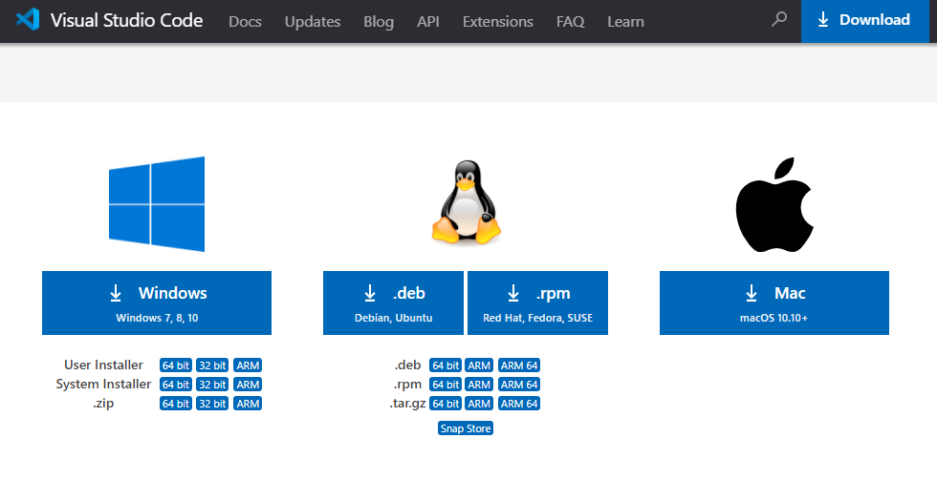

2. Once file is downloaded, run the installer. Choose install location and go through all setting, VS Code will be successfully installed.

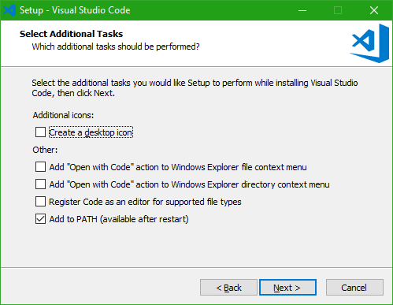

3 It will lead to the following screen. Click on open folder to load exist project.

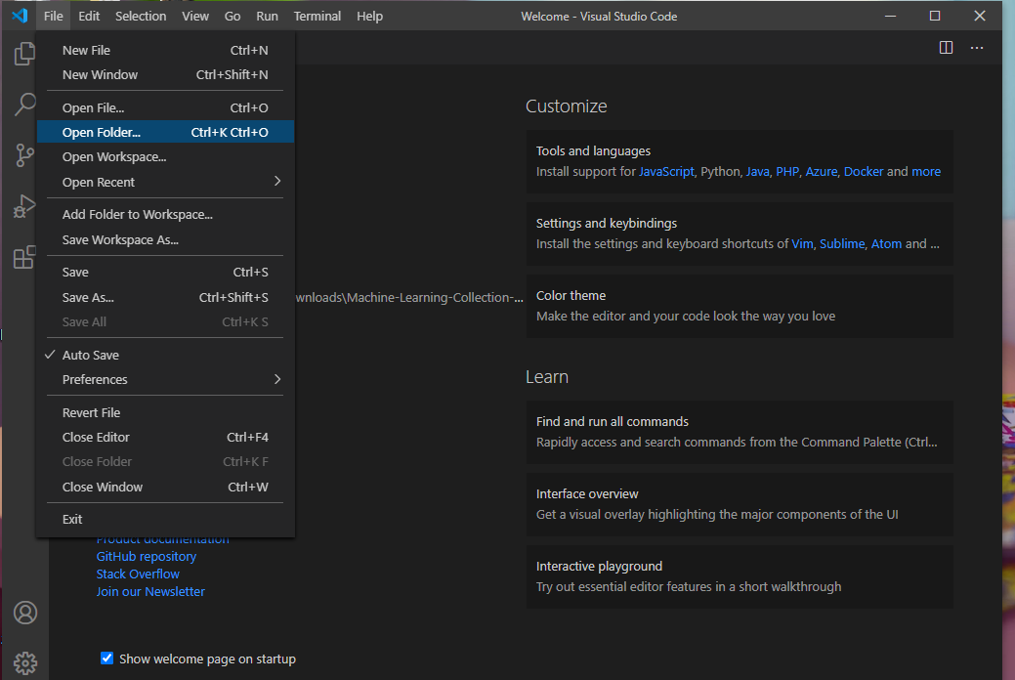

**Node.js**

What is Node?

**Node.js** is an [open-source](https://en.wikipedia.org/wiki/Open-source_software), [cross-platform](https://en.wikipedia.org/wiki/Cross-platform), [back-end](https://en.wikipedia.org/wiki/Front_end_and_back_end), [JavaScript](https://en.wikipedia.org/wiki/JavaScript) [runtime environment](https://en.wikipedia.org/wiki/Runtime_environment) that executes JavaScript code outside a [web browser](https://en.wikipedia.org/wiki/Web_browser). Node.js lets developers use JavaScript to write command line tools and for [server-side scripting](https://en.wikipedia.org/wiki/Server-side_scripting)—running scripts server-side to produce [dynamic web page](https://en.wikipedia.org/wiki/Dynamic_web_page) content before the page is sent to the user's web browser.

**Installation of Node.js**

1 Download the installer from website. Choose correct version and click install.

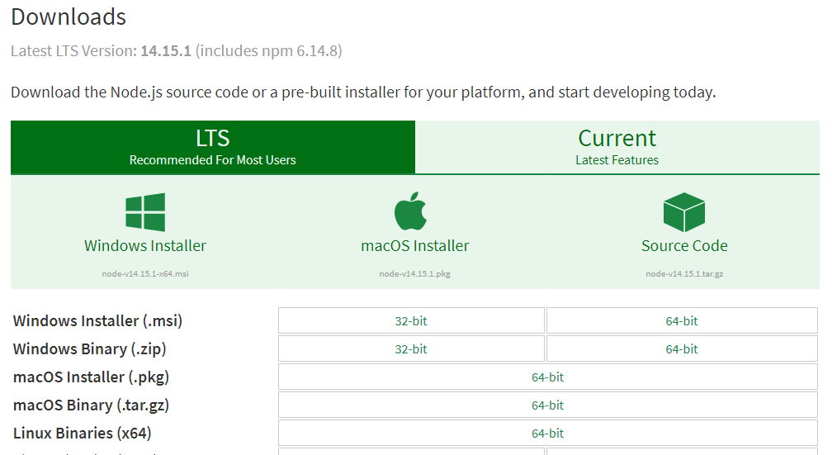

2. Follow the installer’s step and install node in desired location. 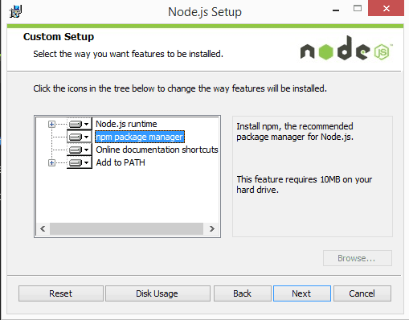

3. Open vs code and press Ctrl + ~ to access terminal. (also, can click on terminal button)

Type “node” and enter. If terminal display node version, the node is installed correctly.

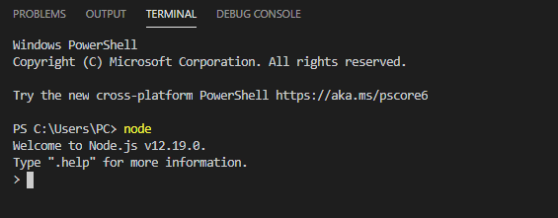

**React.js**

What is react?

**React** is an open-source, front end, JavaScript library for building user interfaces or UI components. It is maintained by Facebook and a community of individual developers and companies.

In order to run this app, the node version need to be >= 8.1. After the requirement meets, user can start the app frontend by type in terminal cd/ Project file location/ front to get the frontend directory.

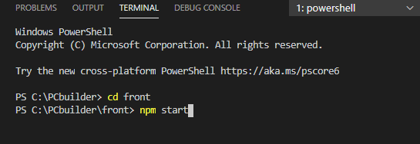

Once in the directory, type: npm install

After the process finished, type: npm start

**Mongo Db**

What is Mongo Db

**MongoDB** is a cross-platform document-oriented database program. Classified as a NoSQL database program, MongoDB uses JSON-like documents with optional schemas.



**Installation of MongoDB**

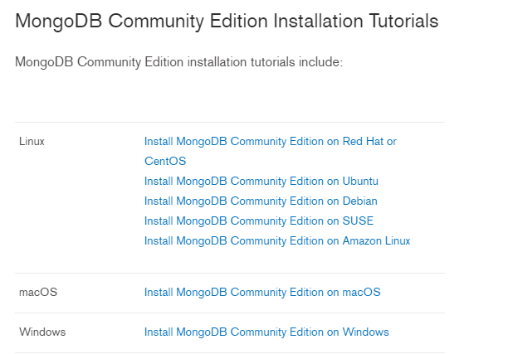

1.Download MongoDB community edition and click on installer.

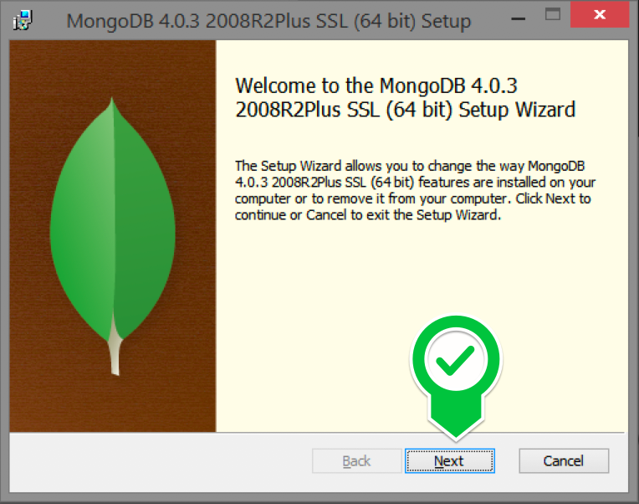

2.Once mongo successfully installed. Open terminal in Visual Studio Code type in terminal cd/ Project file location/ back. Once in directory, type: npm start.

Getting stared with the Pc builder web app.

Once you open the app, you will see the home page.

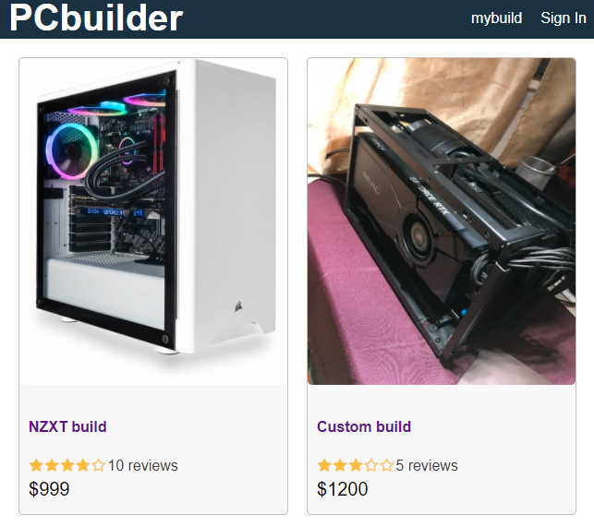

This area is for browse product listed. Free to add product as admin by access the mongo DB compass.

In Mongo DB compass, click on PC builder on the left for a drag down menu which contains product. Click on “Add data” then click “insert document”. Please add data in following format.

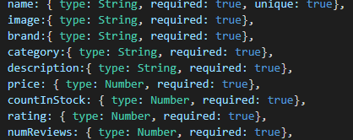

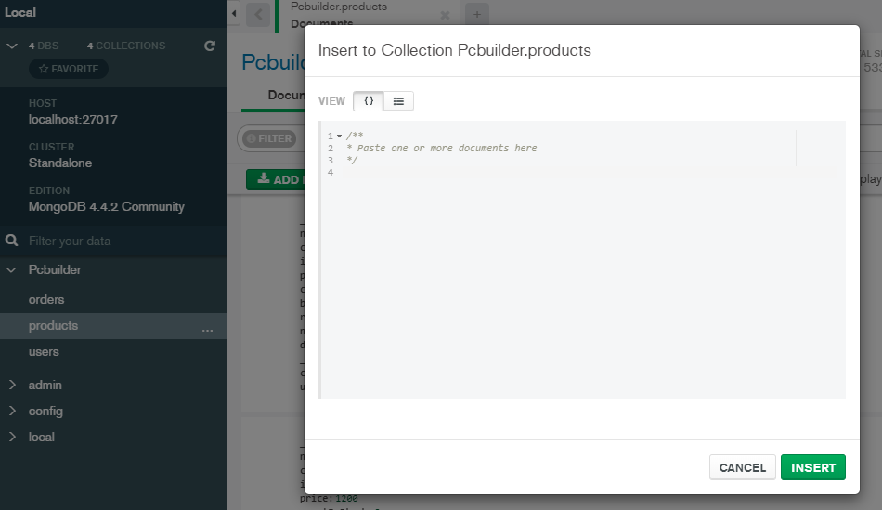

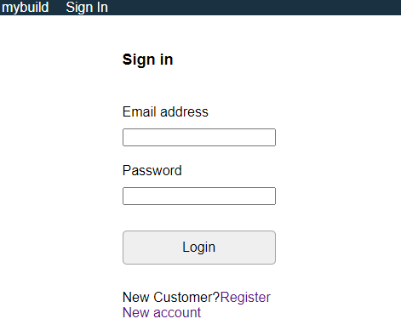

By click on Sign in, the app will redirect to sign in page. On this page, Login in with an existing account Email & Password. If no account, register one by click Register New account button. The app will redirect to register account page.

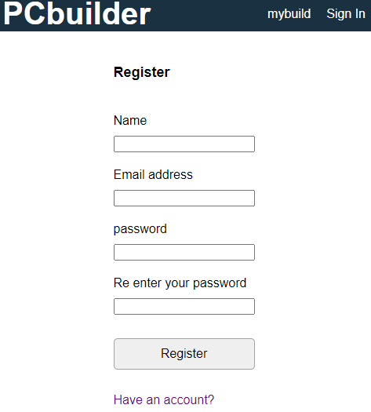

In registration page. By adding all info in correct format. The user will be adding to mongo Db with name, email address, password. Then the app will redirect to homepage with logged in user.

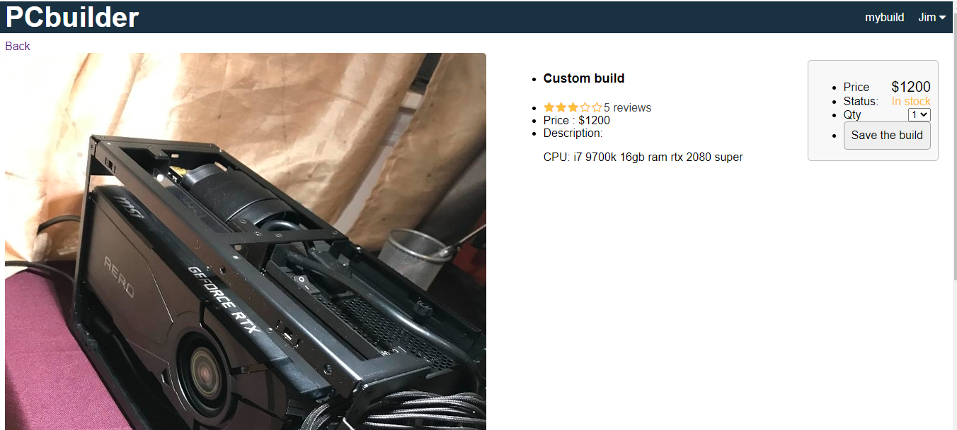

By click on item in homepage, the app redirect to page detail screen. In this page, item price, rating, existing stock will be display. Edit qty and click save the build will add the # of same items to cart.

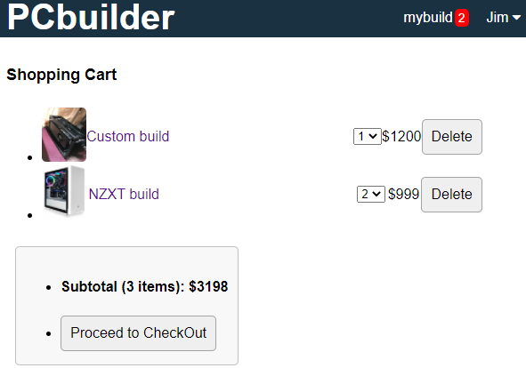

In cart. Edit item number and checking final price. Unwanted item can be deleted by click on delete button. Once finish, click on “Proceed to Checkout” button to continue shipping.

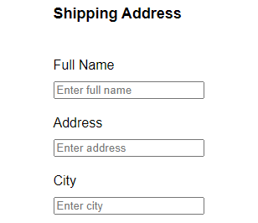 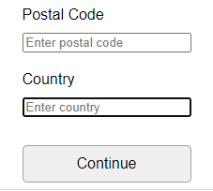

In shipping page. Type in information correctly and click Continue to have shipping info stored in MongoDb.

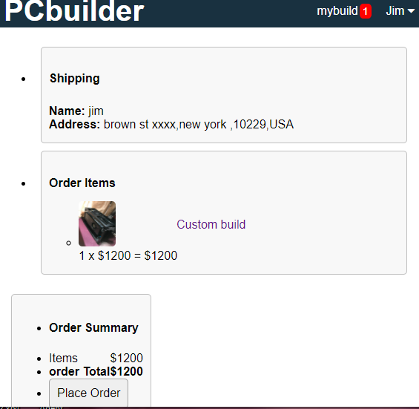

After shipping is entered. App will redirect to item summary page. This page display item image, price, User’s name, and shipping address. Click on place order will save the order to mongo Db and app will redirect to Order detail page.

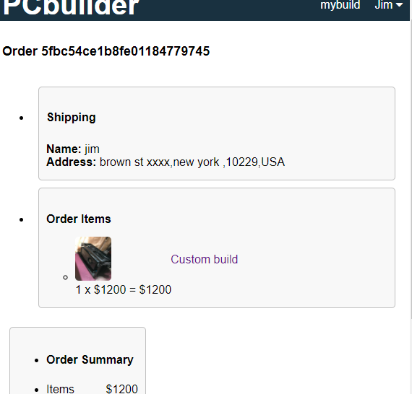

In Order detail page, user can see the order info and a given ID for the order.

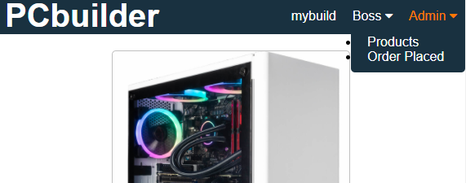

In database, set isAdmin to true will give user admin function.

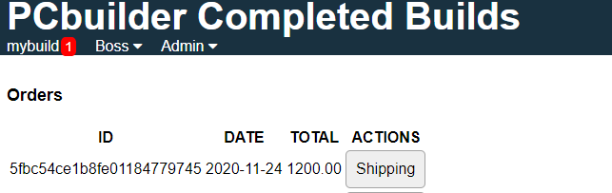

Admin will see order placed by user. Click on shipping will display buyer detail information.

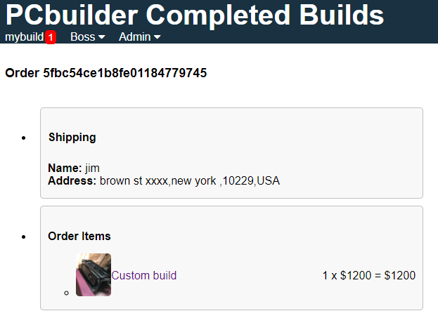

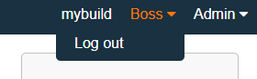

Hover mouse on username and click will bring down menu for log out. Click log out to securely logout.